

IKT203 Algorithms and Data Structures
Project 5: Air Traffic Controller

Date handed out: 29 September 2021
Date submission due: 12 October 2021 23h59

Description

You have been awarded a contract to design and implement an air collision detection system for Safe Airport. Your surveillance system will continuously monitor air traffic within a 100-mile radius of the airport. It will identify the closest pair of aircraft at any given time; if the closest distance is less than 500 feet, the system will sound an alarm. We assume that all aircraft fly at the same height of 10,000 feet.
You will simulate air traffic by continuously updating the position of each aircraft. You may assume that aircrafts arrive within your surveillance area with a constant arrival rate λ. Airplanes travel at speeds between 100 and 1000 knots. Once an aircraft leaves your surveillance area, you are no longer responsible for it. Your program must display the air traffic in a graphics window and find and graphically identify the closest pair at each time step. You may assume that there are no more than 100 planes in your surveillance area at any given time (simply ignore new arrivals if the maximum number of 100 aircraft that are currently traveling thru your surveillance area has been reached).

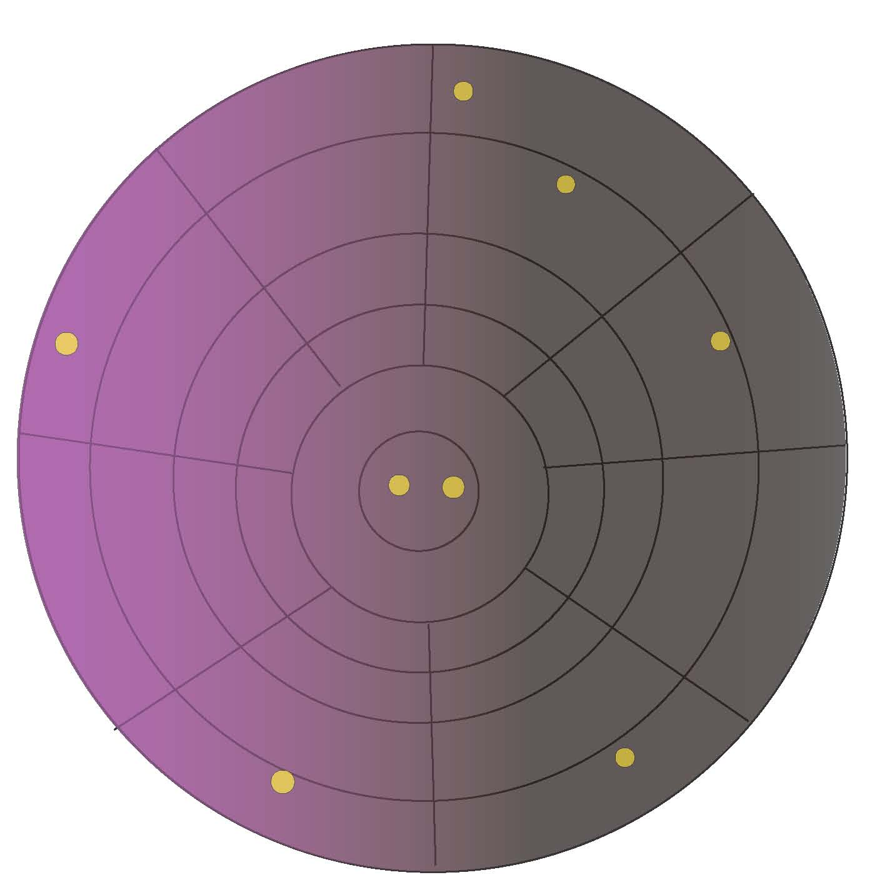

The planes may change their course and cruising speed during their flight thru your surveillance area. The changes in both speed and course will be drawn from a normal distribution.

Programming

We have given you the code of a simplified version of this project. The changes you will need to make are as follows:

- You need to implement the change of speed/course.

- You will need to use a priority queue to hold each flight traveling thru your surveillance area. The flights must be ordered according to the time to leaving your surveillance area, i.e. flights which will leave sooner will be at or near the head of the queue. As the planes change course/speeds, their time to exit may change; that change in departure time must be reflected in the order of the flights.

- Since you know an upper limit on the number of flights, you must implement a static version of a priority queue using a cursor list which implements a linked list using an array.

- You must implement the priority queue as an abstract data type, i.e. InsertQueue, RemoveQueue, EmptyQueue, and FullQueue must be implemented separately from the program that simulates the air traffic. These functions must reside in a separate file and you must define a header file (e.g. priorityqueue.h) that is used by the main program. If you need additional functions to access the data stored in the ADT, then you may implement them.

- You must implement the functions InsertQueue, RemoveQueue, EmptyQueue, and FullQueue to work for any generic data items to be stored in the queue. This is an important aspect of code reuse.

Deliverables

The main deliverable of this project will be a C/C++ program that simulates air traffic and constantly updates the closest pair of flights.

Extra Credit Problem
In computational geometry, it is common to use the term "convex hull" for the boundary of the minimal convex set containing a given non-empty finite set of points in the plane. Unless the points are collinear, the convex hull in this sense is a simple closed polygonal chain. Compute, display and continuously update the convex hull of the flights in your surveillance area.
The gift wrapping algorithm is a simple algorithm for computing the convex hull of a given set of points.In the two-dimensional case the algorithm is also known as Jarvis march, after R. A. Jarvis, who published it in 1973; it has O(nh) time complexity, where n is the number of points and h is the number of points on the convex hull. Its real-life performance compared with other convex hull algorithms is favorable when n is small or h is expected to be very small with respect to n. In general cases the algorithm is outperformed by many others. For the sake of simplicity, the description below assumes that the points are in general position, i.e., no three points are collinear. The algorithm may be easily modified to deal with collinearity, including the choice whether it should report only extreme points (vertices of the convex hull) or all points that lie on the convex hull. Also, the complete implementation must deal with degenerate cases when the convex hull has only 1 or 2 vertices, as well as with the issues of limited arithmetic precision, both of computer computations and input data.
The gift wrapping algorithm begins with i=0 and a point p₀ known to be on the convex hull, e.g., the leftmost point, and selects the point p_{i+1} such that all points are to the right of the line p_{i} p_{i+1}. This point may be found in O(n) time by comparing polar angles of all points with respect to point p₀ taken for the center of polar coordinates. Letting i=i+1, and repeating with until one reaches p_{h}=p₀ again yields the convex hull in h steps. In two dimensions, the gift wrapping algorithm is similar to the process of winding a string (or wrapping paper) around the set of points.

Example:
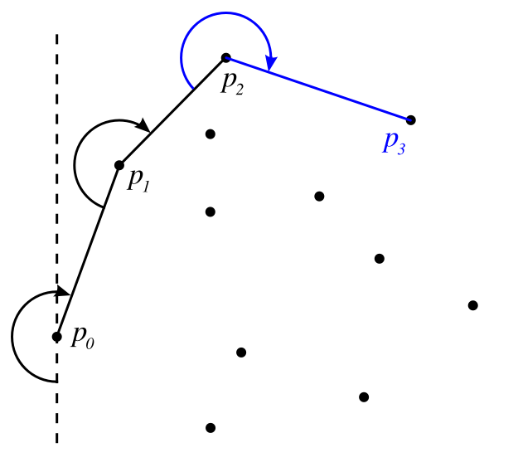

Grading

The breakdown of the grading will be as follows:

Aspect | Marks
Initialization of a static priority queue based on cursor linked list implementation | 10
Inserting elements at the right position in a static priority queue | 20
Removing elements from the head of a static priority queue | 10
Testing for empty/full static priority queue | 10
Update of static priority queue for change of course/direction | 20
Finding the closest pair of flights | 10
Separate header files | 10
Generic implementation of static priority queue | 10
Total | 100
Extra Marks
Finding the convex hull | 20
Total | 120

